Name: Nour Eldeen Mahmoud Abdelghafar

B.N: 1000

Date: 3/7/2020

Topic name: artificial intelligence

GIThub link : <https://github.com/nou807/HTML-PROJECT-REPOSITORY1>

Application Brief: Artificial intelligence (AI) is the ability of a computer program or machine to think and learn. And it's a field of study that tries to make computers "smart". They work on their own without instructions.

Generally, the term "artificial intelligence" means a system that mimics human understanding. At least some of the things we associate with other minds, such as learning and problem solving can be done by computers, though not in our own way. Andreas Kaplan and Michael Haenlein define AI as the ability to systematically interpret external data, learn from that knowledge, and apply those learning to achieve specific goals and tasks in a flexible way.

**Screen Shots:**

1. 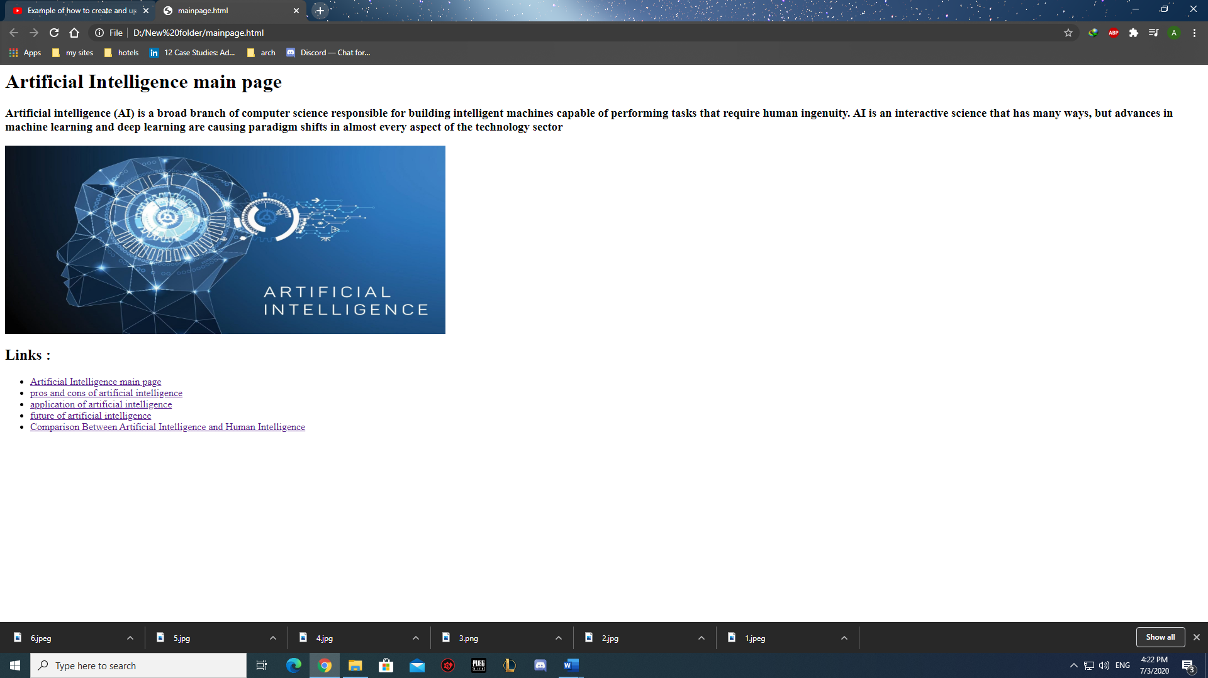Main page
2. 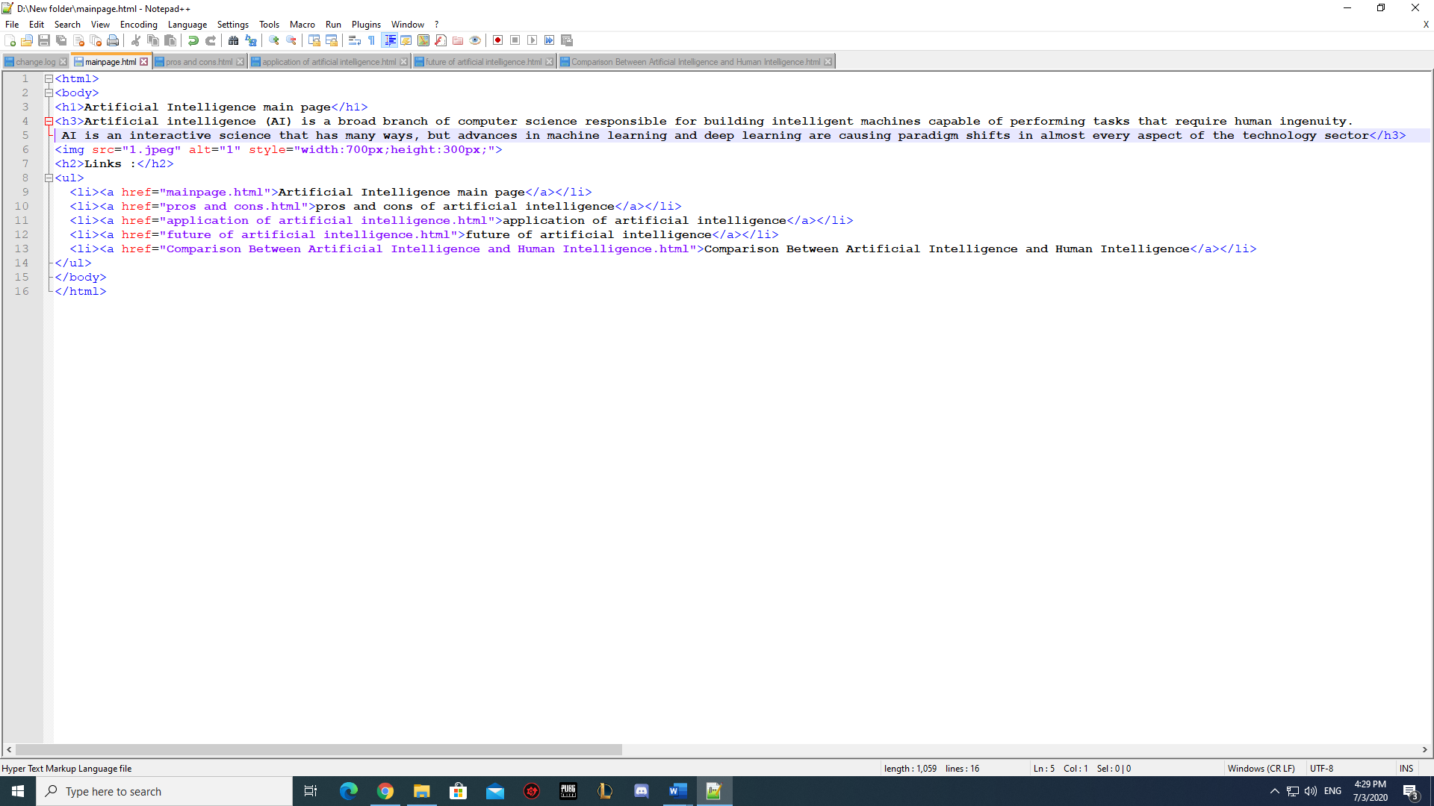Main page codes
3. 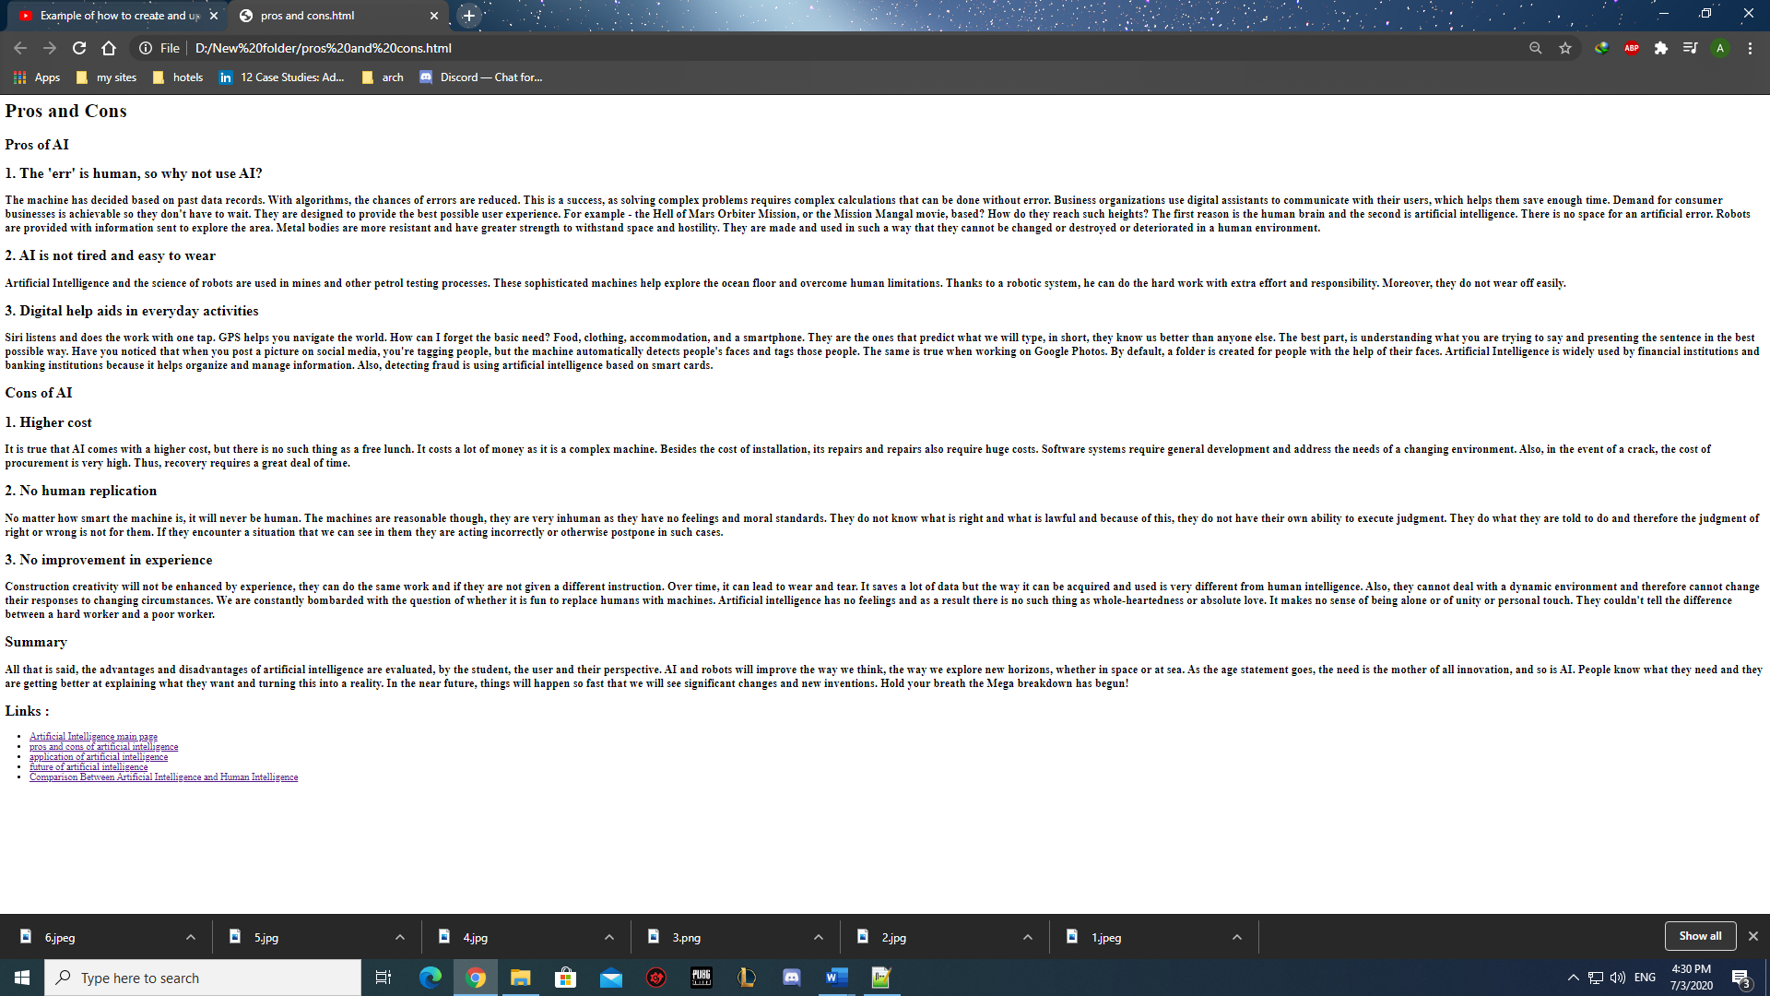pros and cons
4. 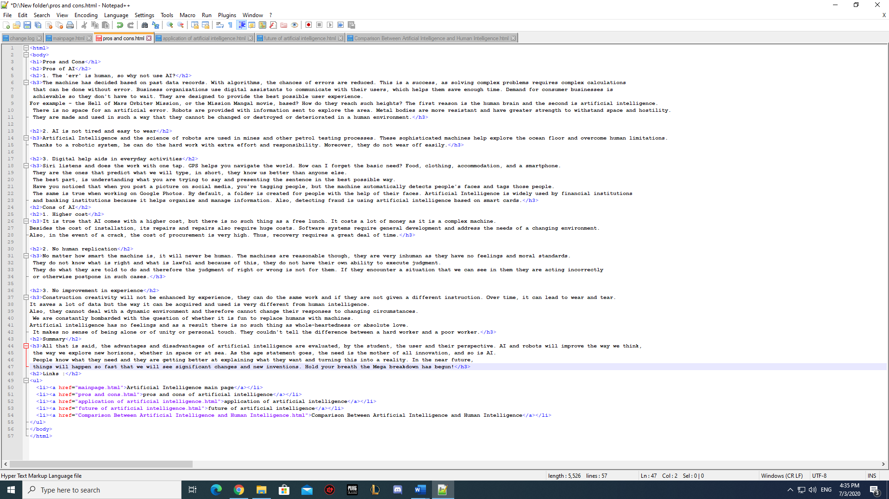Pros and cons codes
5. 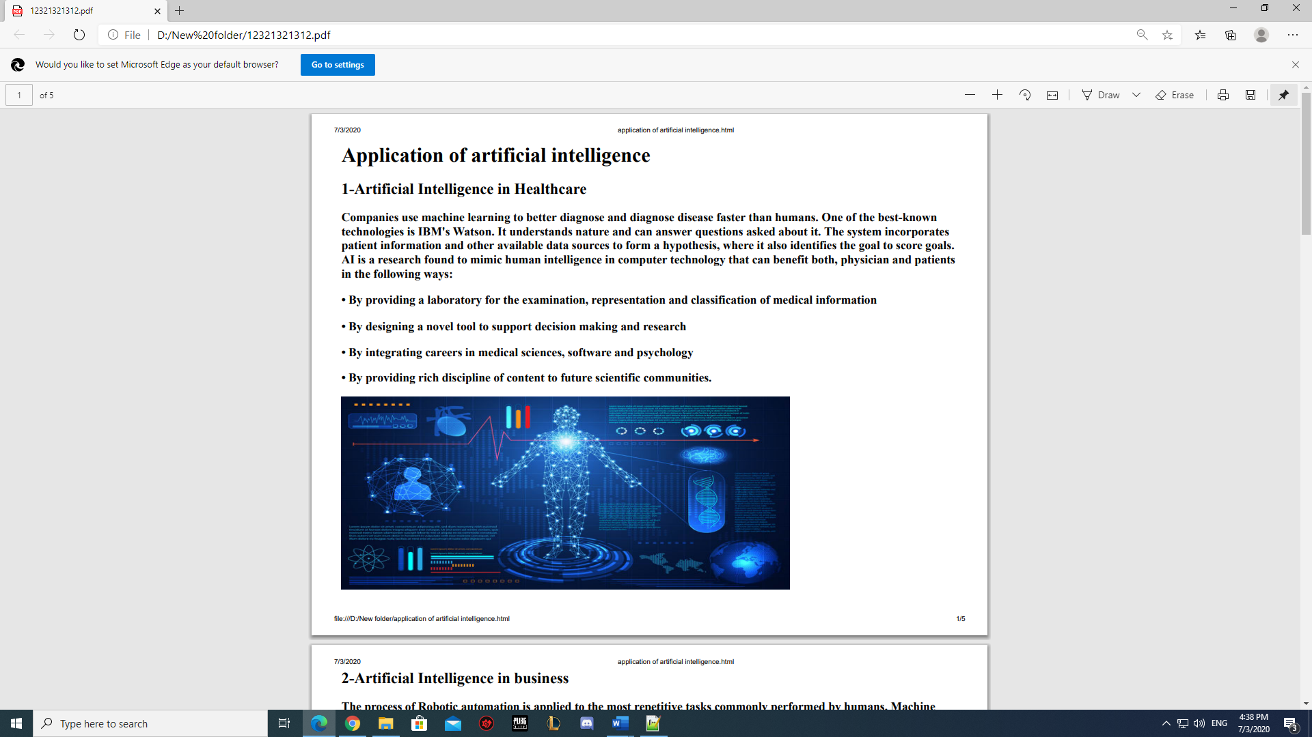application of artificial intelligence

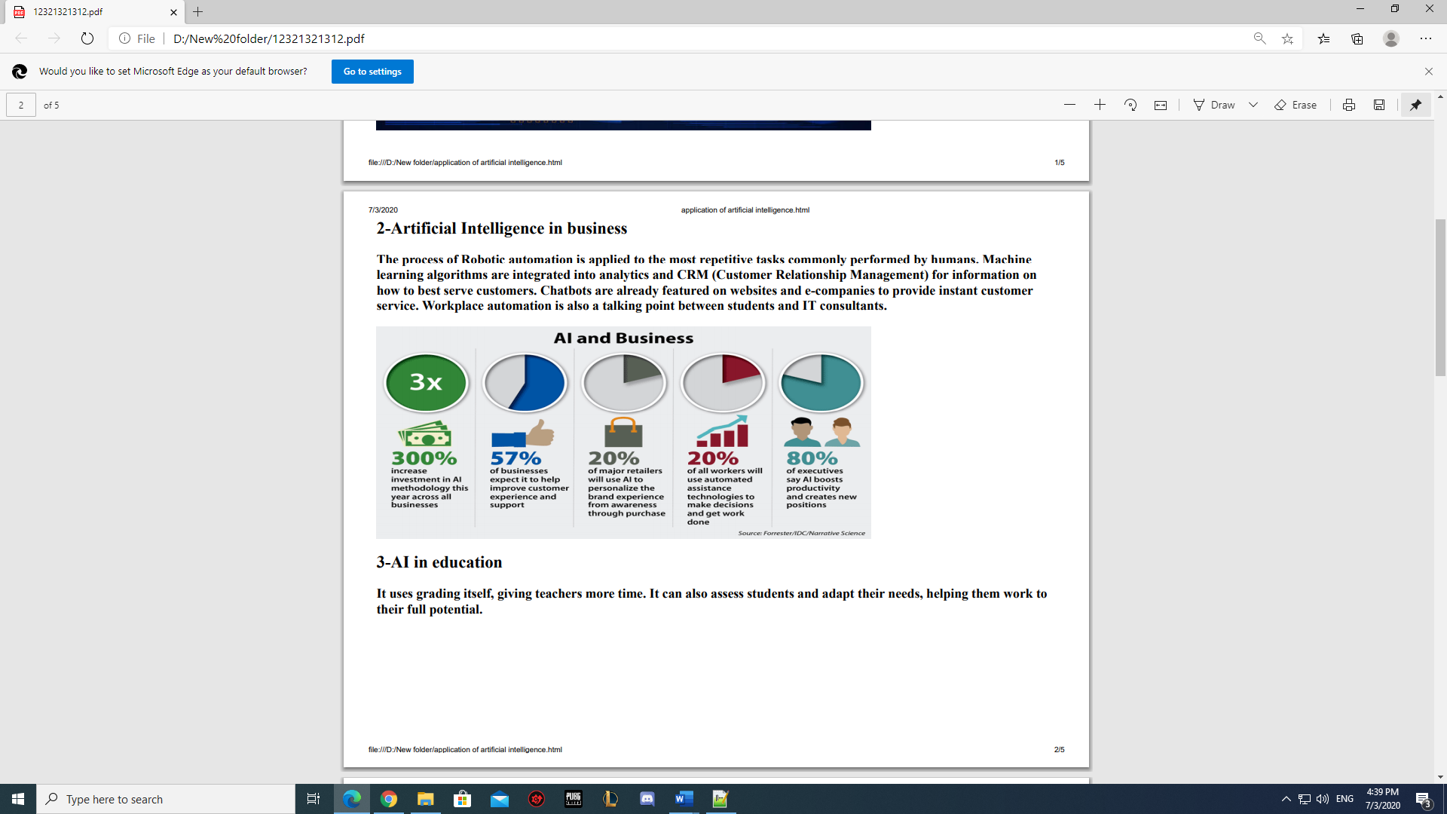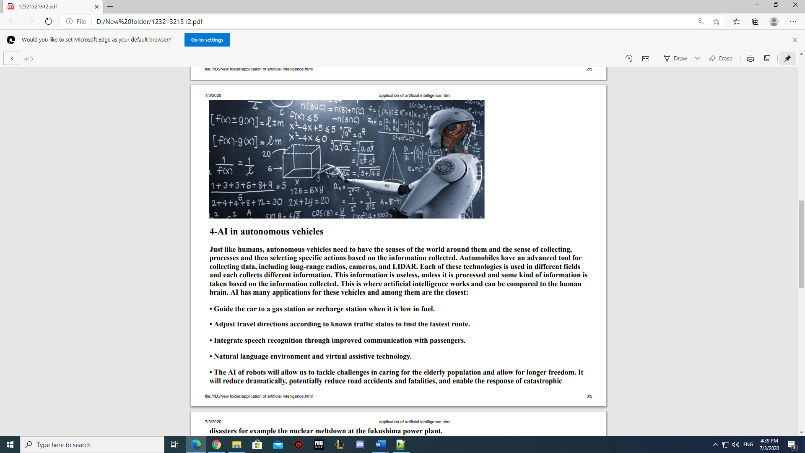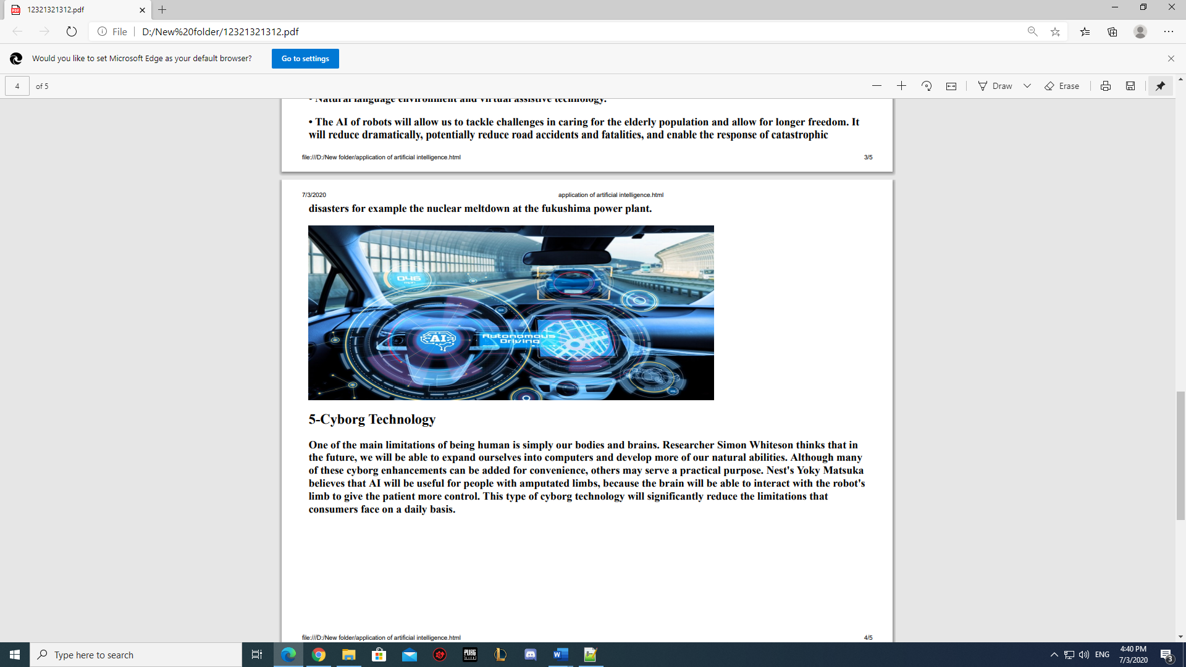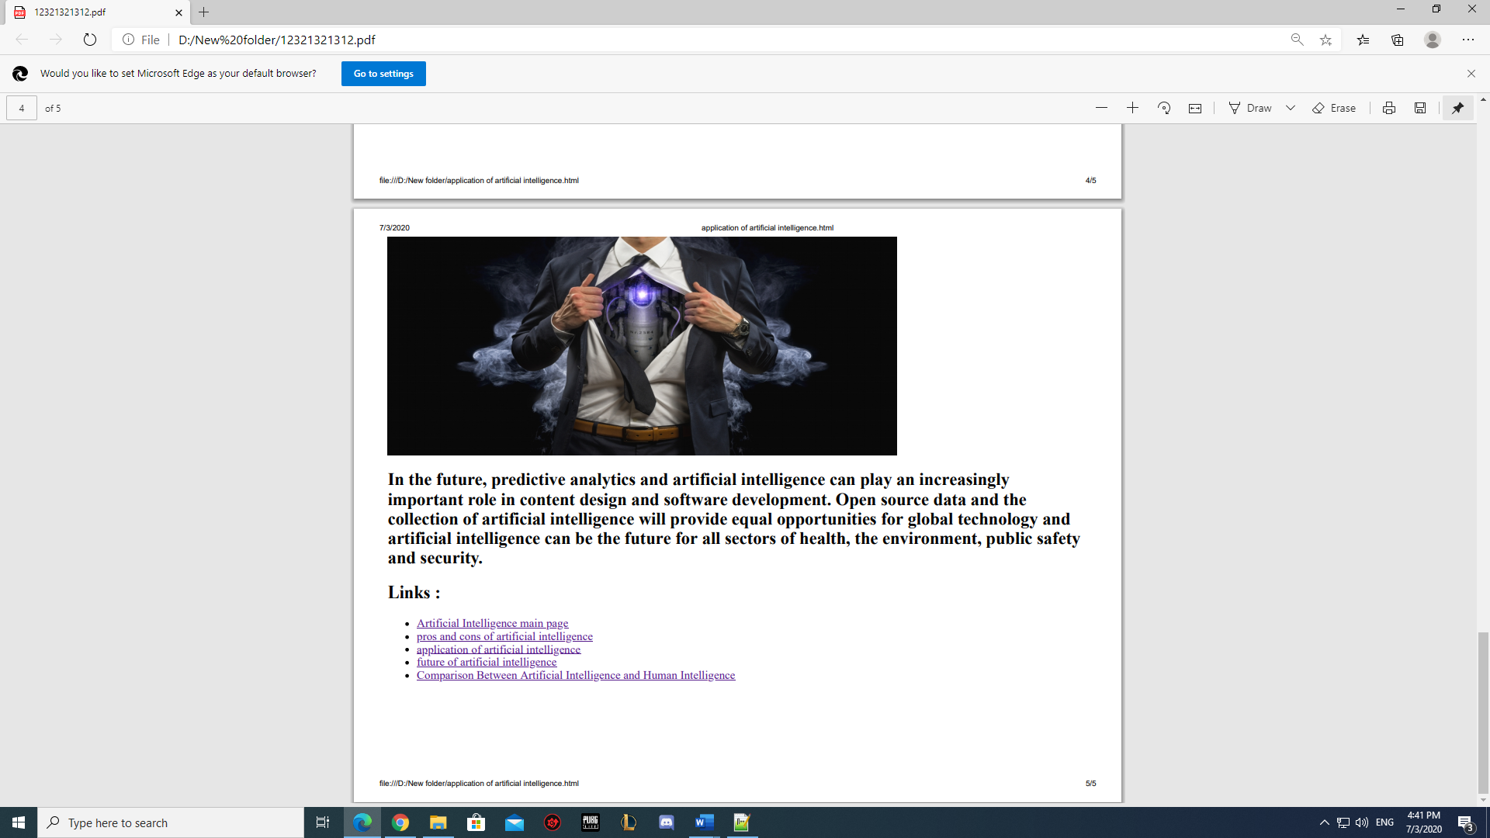

1. 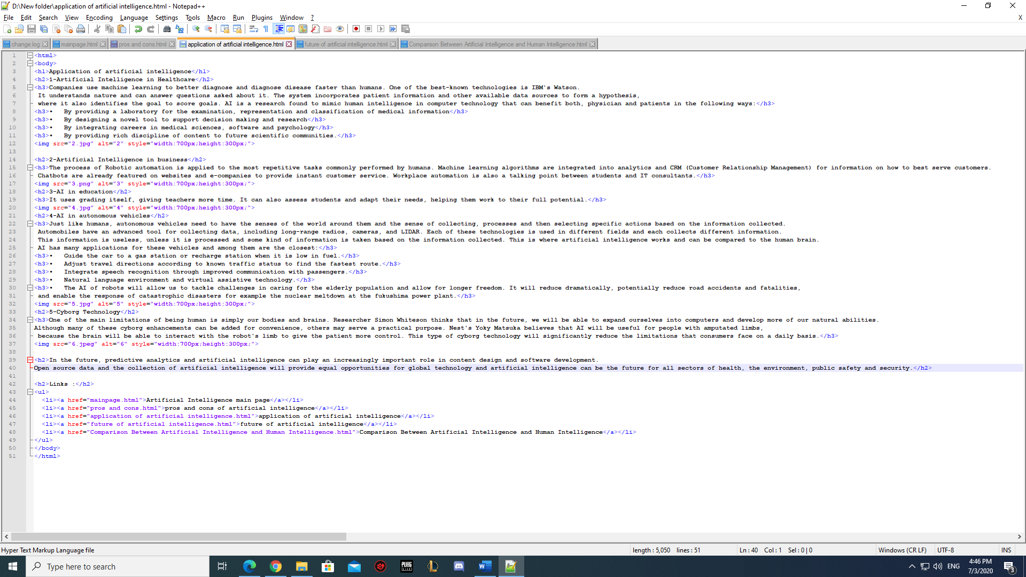application of artificial intelligence codes
2. 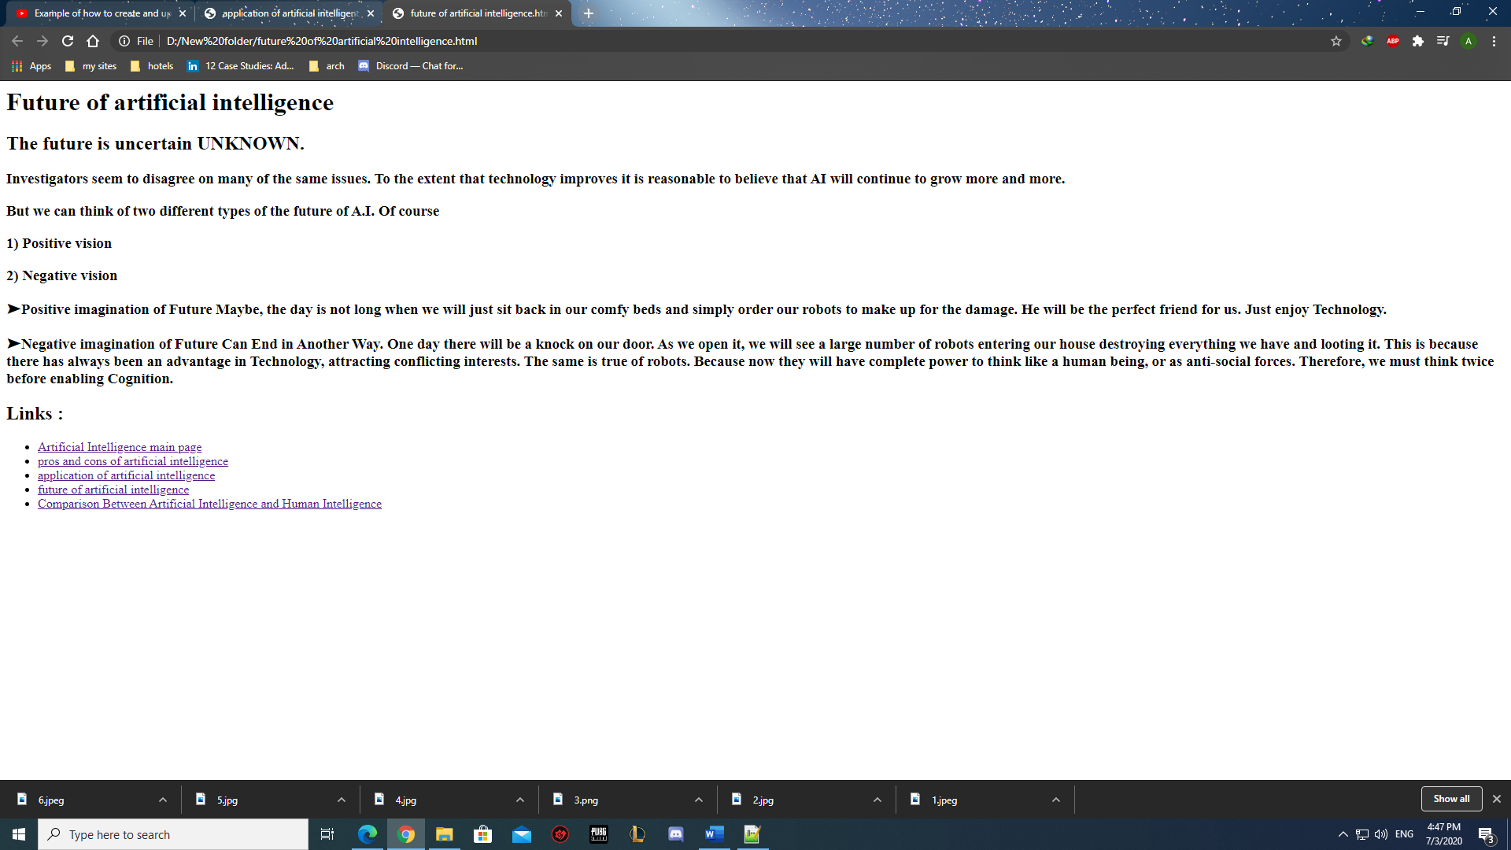future of artificial intelligence
3. 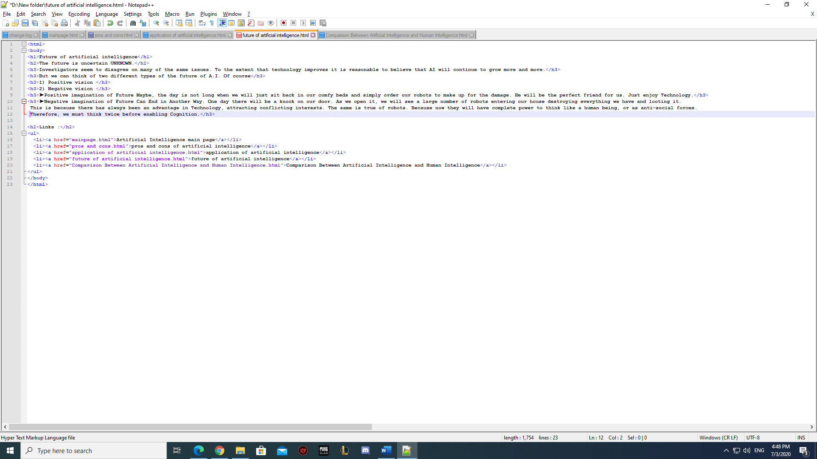future of artificial intelligence codes
4. 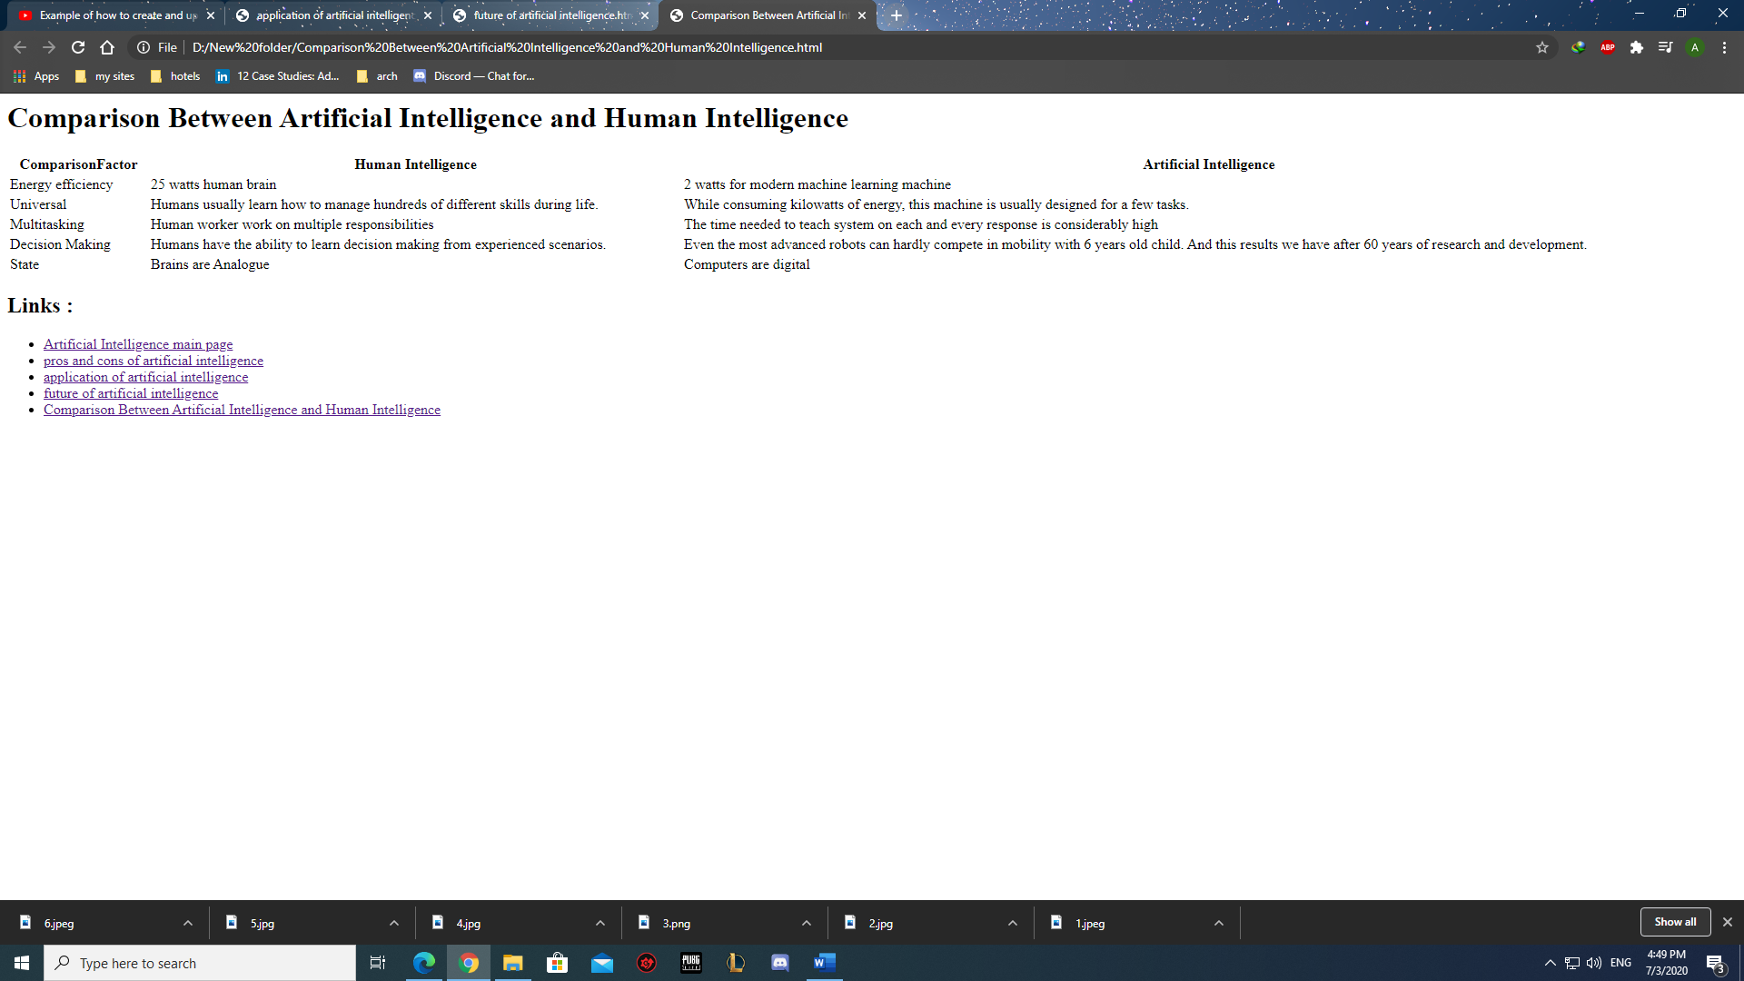Comparison Between Artificial Intelligence and Human Intelligence
5. 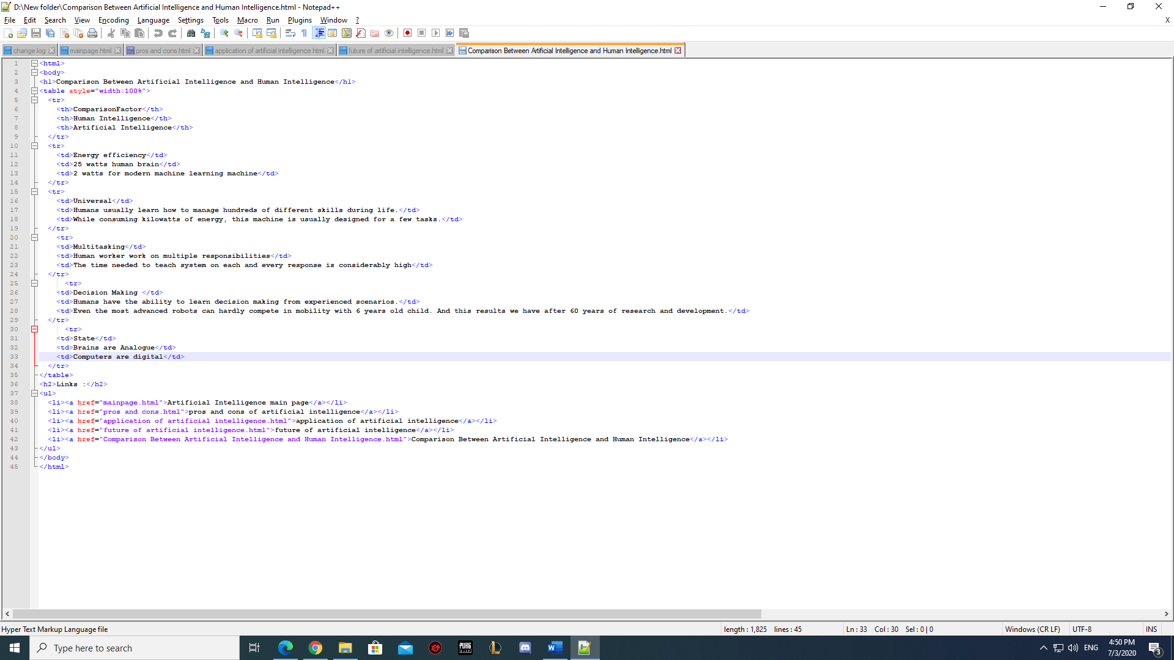Comparison Between Artificial Intelligence and Human Intelligence codes